MODULE 02

TENSES (ACTIVE VOICE)

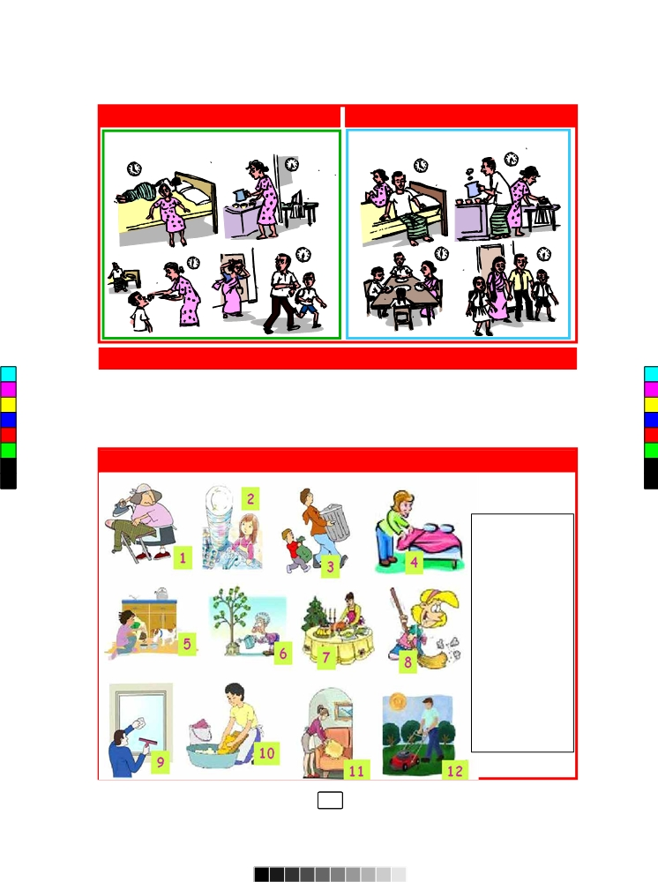

Warm-up Activity
How do you spend your day at the university?

MDR
Speak about the morning routines of the two families below.
- Which routine do you think is better? Why do you say so?
Vocabulary
housework, unity, collective effort, understanding, cooperation, blame, responsibility, duty, equality, inequality, feminism, women’s double burden,
Tense Pairs; Simple Present Tense & Present Continuous Tense
Simple Present Tense
Tense | Rule | Function
Simple Present Tense | Subject + Do/Does + V1 + Object | - Something true in the present  - Repeated actions  - Actions scheduled in the near future  - Facts & habitual actions
Present Continuous Tense | Subject+ am/is/are+ V1+ ing + Object | - Something happening at the moment of speaking  - Show that something is changing, growing  - Temporary situations  - Talk about the arranged future

I live in Sri Lanka (Simple present Tense)
I am living in Sri Lanka (Present Continuous Tense)
The Present Simple Tense is used in science writing to state accepted facts/truth.
Smoking increases the risk of heart diseases. (General truths)
The temperature increases linearly over time. (Generalises the experimental observation)
- Astronomers observe planets, starts, galaxies and other celestial objects. (Plural subject)
- The astronomer observes planets, starts, galaxies and other celestial objects. (Singular subject)
- The astronomer doesn’t observe planets, starts, galaxies and other celestial objects.
(Negative structure)
- Does the astronomer observe planets, starts, galaxies and other celestial objects?
(Yes/No Question)
- Why does the astronomer observe planets, starts, galaxies and other celestial objects? (Wh-Question)
- Who observes planets, starts, galaxies and other celestial objects?
Group work
The list of verbs given in the box provides examples of verbs that express communication actions. Use them in meaningful sentences using simple present tense structure.

Present, describe, illustrate, explain, propose, summarize, provide, report, offer, clarify

- Present ……The paper presents the consequences of environmental hazards………..
- Describe……The paper………………………………………………………………..
- Illustrate………………………………………………………………………………..
- Explain…………………………………………………………………………………
- Summarise………………………………………………………………………………
- Provide………………………………………………………………………………...
- Offer……………………………………………………………………………………
- Clarify………………………………………………………………………………….
- Propose…………………………………………………………………………………
Present Continuous Tense
A renowned food scientist is developing a safe packaging system to store food.
I am developing a safe packaging system to store food.
Food scientists are developing a safe packaging system to store food.
Food scientists are not (aren’t) developing a safe packaging system to store food. (Negative sentence)
Are Food scientists developing a safe packaging system to store food? (yes/No Question)
Why are Food scientists developing a safe packaging system to store food? (Wh-Question)
Who Are developing a safe packaging system to store food? (wh-Question)

Cookery Show
In groups, get ready to demonstrate a cookery programme in front of the class.
Pol Sambol, Desert, Tea, Roti,etc.
Point to remember
Verbs that express feelings or thoughts are not normally used in continuous tenses in certain cases – appear, need, prefer, dislike, understand, know, remember, want, love, be, recognize, sound

Narrating Stories
Reading and writing
  - Pre-reading
    - Are you familiar with the stories of Nasreddin and Mahadenamutta?
    - What kind of stories are they?
    - Mahadanamutta is meant to be a wise man. Is he truly a wise man? Compare Mahadanamutta’s character with Nasreddin’s character. Discuss with your partner.
Nasreddin and the visitors
One day a visitor came to Nasreddin’s home. “I am your cousin from Konya”, he said, “and I have brought you a duck to celebrate the visit”. Nasreddin was delighted. He asked his wife to cook the duck and served the visitor a fine dinner.
The next day another visitor arrived, “I am the friend of the man who brought you the duck”, he said. Nasreddin invited him in and gave him a good meal. The next day another visitor arrived and he said,
“He was the friend of the friend of the man who had brought the duck”. Again Nasreddin invited him in for a meal, however he was getting annoyed. Visitors seemed to be using his home as a restaurant.
Then another visitor came and said “I am the friend of the friend of the friend of the man who had brought the duck”.
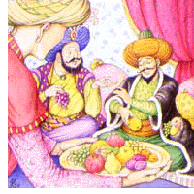
Nasreddin invited him to eat dinner with him. His wife brought some soup to the table and visitor tasted it.”What kind of a soup is this?” asked the visitor.
“It tastes just like warm water”
“Ah!”said Nasreddin, “That is the soup of the soup of the soup of the soup of the duck”.
Comprehension
  - Read the above story and answer the questions given below.
- How many visitors came to Nasreddin’s house
………………………………………………………………………………………………..
- Was the decision made by Nasreddin wise?
……………………………………………………………………………………………….

Story Narrating (7 minutes)

Start narrating the story in your own words to your partner. Stop halfway in the story ans ask the partner to continue.

Creative Extension (Speaking Activity)
- Suggest a better ending for the story in groups
- What would have been the solution if this happened in Mahadanamutta’s house? (you can make your answer funny and absurd)
- Discuss and write a story of Mahadanamutta. Alter the ending of the story and you can make is as absurd and as humorous as you like!
Simple Past Tense & Past Continuous Tense
Simple Past Tense

Tense | Rule | Function
Simple Past Tense | Subject + Did + V1 + Object | - Something happened once in the past  - Something happened again and again in the past
Past Continuous Tense | Subject+ was/were+ V1+ ing + Object | - Something happened before and after a particular time  - Something continued for some time  - Show change/growth  - Talk about the arranged future

- Scientists designed a machine to lift stones.
- Scientists didn’t design a machine to lift stones. (Negative structure)
- Did scientists design a machine to lift stones? (Yes/No Question)
- Why did scientists design a machine to lift stones? (Wh-Question)
- What did scientists design to lift stones?
- Who designed a machine to lift stones?

Task 01(Group work)
The list of verbs given in the box provides examples of verbs that express communication actions. Use them in meaningful sentences using simple past tense structure.
Apply, assess, calculate, explore, measure, evaluate, develop, investigate, compare, design

- Apply .……We applied for the extended degree programme…………………………..
- Assess…………………………………………………………………………………
- Explore.………………………………………………………………………………..
- Compare.………………………………………………………………………………
- Develop...………………………………………………………………………………
- Design.………………………………………………………………………………...
- Investigate……………………………………………………………………………..
- Measure……………………………………………………………………………….
- Calculate………………………………………………………………………………

Past Continuous Tense
- An environmentalist was fighting for the carbon tax.
- Environmentalists were fighting for the carbon tax.
- Environmentalists were not (weren’t) fighting for the carbon tax.
- Were environmentalists fighting for the carbon tax? (Yes/No Question)
- Why were environmentalists fighting for the carbon tax? (wh-Question)

Pre-reading Activity
- How often do you read books?
- Do you thing reading books is a good habit? Why?
- Do people read books nowadays? If so, why?

Reading
I have been collecting story books since I was very little. I have read most of them. They are the greatest treasure that I own.
I am what I am because of what I have read. Books have taken me to places where no one else has taken me. I have become a soldier, a warrior, a princess, a maid, a magician, a witch, a miracle worker in the pages of books. I have cried, I have laughed, I have loved, I have hated, I have fought and I have found solace with the characters of books as they go through their lives. I know people have become stronger, they have gathered more courage, they have taken better decisions, they have become better people because of what they have read.
I have been telling everyone to read more books from the time I started to love them. But many people don’t read them. They say it is a waste of time. They say it doesn’t show reality. They say there is nothing they can learn from them.
But I know these people are wrong. I have seen such people become stressed. I have watched them make bad decisions. I have heard them complain much about life. I have realized that they are not often happy. And I have come to understand that it is because they are very much alone. They don’t have the hundreds of people that readers have around them who have taught them many lessons about life. I have been taught by some of the best fictional characters ever to enter this world. And sometimes, they are much better people than the ones living.
MRD

Comprehension
- What is the narrator’s greatest treasure?
- What has made the narrator become what she has become?
- What are the benefits of reading fiction according to this narrator?
- Why don’t some people read story books? What reasons do they give?
- What happens to people who don’t read, according to this narrator?
- Who is teaching the narrator to become a better person?
- Do you agree with what the narrator is saying? If so, why? If not, why?

Language focus
The Present Perfect tense
Use: When an action is finished but the results are still felt, this tense is used.
This whole passage describes what the narrator has become (what she is now) because of the past action of reading books.
Books have taken me to places where no one else has taken me.
I have realized that they are not often happy.
Don’t give me any tea. I have had lunch just now. (So the result is having a full stomach, which is relavent to the context.)
The structure of the present perfect tense is:

Active voice | Subject | + has/ have | + verb 3(Past Participle) | + object.
 | Mother | Has | Cooked | Rice.

The shop keeper has opened his shop.
Active voice: Mary has bought a frock.
(Negative): Mary has not brought a frock.
(Question) : Has Mary brought a frock?

Negatives (In negatives, the word ‘not’ comes between the auxiliary and the main verb.)

Please give me something to eat. I have not had lunch yet.
I have not washed my hands, so I cannot eat at the moment.
Yes/no question (The auxiliary have inverts its position with the subjects.)
Have you taken your passport? Yes, I have (taken my passport).
Wh questions (in subject position, simply comes where the subject comes.)
What has happened here? There has been an accident.
Who has gone to America? I have.
How many lives have been lost because of the war?
In a non-subject position, comes in front of the yes/no inverted pattern.
Where has Sunil taken the book? He has taken it to the canteen.

Writing
Your friend ask to keep her/his brother who is stubborn and mischievous in your house for a week. Write a letter to your friend who is out of Colombo, mentioning about what her brother has done during the work.

Speaking (Role Play)
Recruiting Babysitters
- Have you had a difficult babysitting moment? How do you handle the situation?
- Have you ever handled a child emergency?
- Have you ever tried to do any paintings/craft work with children?
- Have you ever slept while baby sitting?
- How do you comfort and discipline children? Have you ever hit a child? Why?
- Have you used intoxicated drinks and methods to make the child sleep?
- Have you ever used your first aid knowledge? When?
- Have you had any problems with the previous customers?
- Have you done or followed any training of child development?
- Why have you left the earlier house?
- Have you ever gone to the Police regarding a child issue?

Past Perfect Tense
Form: had + past participle
Active voice | Subject | + had | + verb 3(Past Participle) | + object.
 | Mother | Had | Cooked | Rice.

Use: When there are two actions in the past, and the first action is over before the second action happens, the first action is in the past perfect tense. The second action is normally in the past simple tense.
When Heln Keller died in 1968, she had changed the world for the better, especially for the underprivileged.
She had set up centers to help visually handicapped people all around the world.
She had also become a radical socialist, speaking about and working for the rights of workers.
Exercise
A. Fill in the blanks correctly with the correct form of verb.
1. When I ……………. (come) home yesterday, my children ………………….. (fall
asleep.)
2 When Sunil ……………. (go) to the USA, his daughter …………………….. (get) her
degree.
3. When Amila ……………………. (enter) university, she ……………. already ………………… (do) her CIMA examinations.
4. When Sri Lanka …………… (come) to the final round in the cricket World Cup, it ……………. (defeat) India.
5. When the police finally ……………… (catch) the thief, he ……………………….. (steal) much money from many houses.

Post-reading activities
Speech
Prepare a speech that you will give a group of very young children about overcoming any challenge that they might have to face in their life. You can use an inspirational figure like Helen Keller if you wish, to exemplify your point.

The Present Perfect Continuous Tense

Look at these examples from the passage.
I have been collecting story books since I was very little.
I have been telling everyone to read more books from the time I started to love them.

These verbs are in the present continuous tense.
Form: have + been + present participle
Use: This is used when the action started in the past but is still going on. Usually, the time period is specified, either by using the preposition ‘since’ to show the starting point in time, or ‘for’ which shows the whole period of time.
I have been teaching here since 2002.
I have been teaching here for 13 years.

Points to remember
There are some verbs that cannot be used in the continuous tense: verbs which show a mental status like ‘love’, ‘understand’ and ‘want’ and ‘quick’ verbs like ‘stop’, ‘catch’, ‘arrive’, ‘explode’ etc.

Task 03
Exercises
a. Put the verb and the preposition correctly in the blanks.
I ………………………….. (wait) here ………….. 2 hours. He has still not come.
The teacher ……………….. (teach) ……… only 20 minutes but the students have already understood the important points.
Please hurry. The patient ………………………. (cry) …………… he woke up.
Nimali ……………………. (come) to this school …………. 2011.
People …………………………… (ask) for reforms …………. a long time.
b. Look around you and think about what you have been doing upto now. Write five sentences about it. Remember to mention the time factor.

Speech activity
Look at the pictures below and write the dialogue that the boy and the girl will be having. Use as many past perfect continuous verbs as possible.

Grammar through literature
The Search
MDR
I have been searching ever since I was born
I have been looking for so long
I have been waiting, I have been longing
I have been praying I’ll be strong

To know that you will come, to know that you are there
Somewhere, some place I’ve yet to see
And you’ll tell me when we meet, you too have been seeking
And you’ve found your answer, in me.

Comprehension
- What has the poet been searching for?
- Has she found what she is looking for?
- What does she want the person she is looking for tell her, when they finally meet?

Speech Activity
Look at the pictures below and make a story. Predict what will happen next? Role play the story.

Vocabulary
matchmaker, groom, bride, poruwa, garland, betel sheaf, horoscope, walking stick, auspiscious time, matching horoscopes, poruwa ceremony, national dress, bridal saree, in-laws, relations, parents, discussion, dowry, proposal, arranged marriage, love marriage, elopment

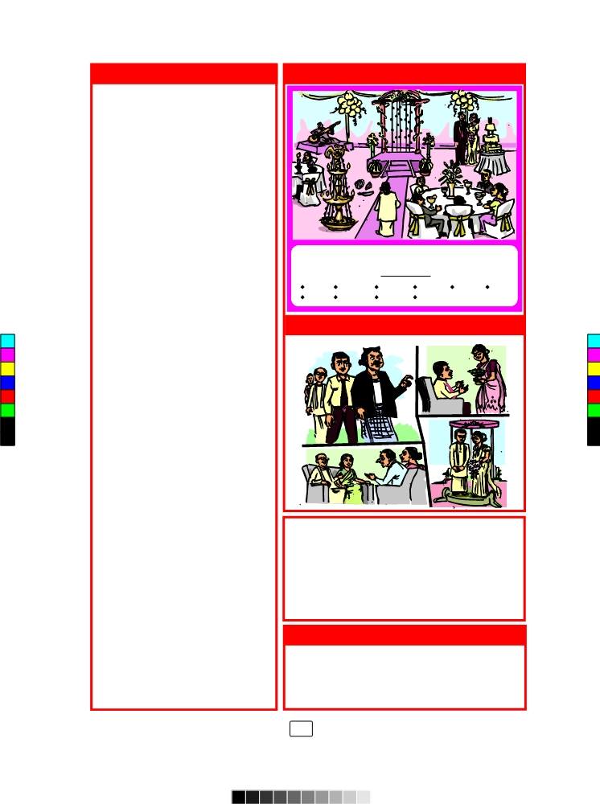

- The End -

